

Houbara displaying Males Standardized Circular Observation protocol (MSCO) in North Africa

Writer: Thibault Dieuleveut
Reviewers: Christelle Lucas,
Version: 1
Date: 01/03/2021

Table of content

I. Generalities 3
II. Field sampling design 3
III. Houbara MSCO specifications 4
IV. Operating mode 4

I. Generalities

Standardized circular observation (SCO/MSCO) protocols are based on observation points and designed following standards of distance sampling analyses. The data are collected in a way that allows to extract density or abundance of the targeted species in a given area.

They consist in a set of circular observations (360°) performed to detect the targeted species. They are standardized in the sense that the period, number of observers, observation tools, observation duration and spatial location of observation points are pre-determined.

The key data collected is the distance between observers (observation point) and the groups (or single individuals) observed of the targeted species, as well as the group size.

Few basic assumptions need to be verified for the method to be valid:
- Targeted species distribution is random and independent of observation points;
- Distance are measured accurately;
- Detection at low distance is perfect;
- No induced movement by observers before detection.

II. Field sampling design

The reference observation points are coming from a regular grid (generally 3 km between points, but this can be different due to protocols setting history – cf Al Baten). This grid is validated once, and each point can be moved until 300 m away from the theoretical one to provide better visibility. This validated grid will remain the basis for all upcoming surveys and will not be modified anymore. This validated grid is definitely stored in EcoRelevé database and then extracted and uploaded to GPS for each survey.

In order to get a better area coverage, a second grid of same step can optionally be interposed. In this case, the second grid is surveyed only after the first one is completed, to avoid direct perturbations due to proximity between points.

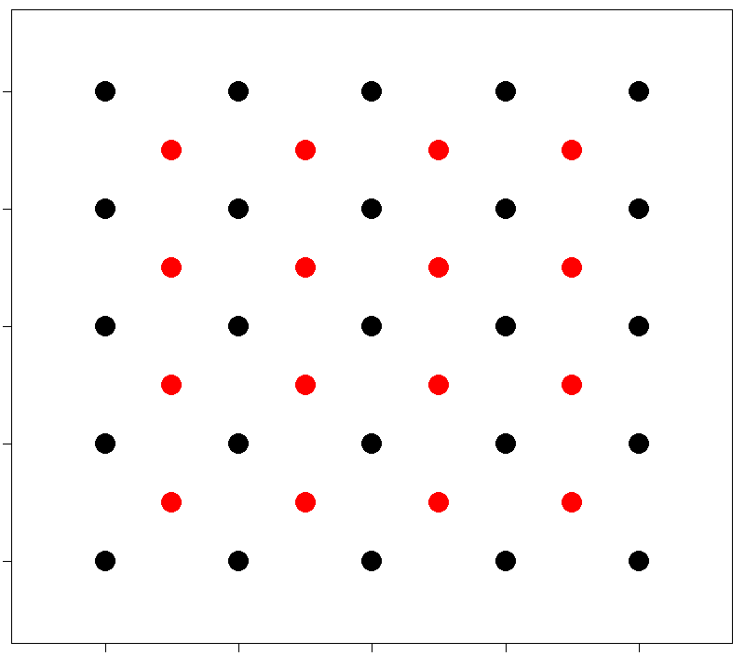
Figure 1. Theoretical example of a grid (black dots), with a second grid interposed (red dots).

One full coverage of every points corresponds to one session. According to local specifications (to cover the whole displaying period), up to 8 passages can be performed successively (with small temporal gap between them). The periods chosen for each passage is area dependent.

III. Houbara MSCO specifications

Target: Displaying males (any males showing at least white neck feathers widely extended or up)
Observation duration: 10 min.
Number of observers: 1.
Tools: Binoculars.
Position of observers: On pick-up bed or step of the car.
Angle covered by each observer: 360°.
Period in the day: Morning (within 3 hours after sunrise) and, if relevant, evening (within 2 hours before sunset).
Period in the year: Breeding season.

IV. Operating mode

The observers reach the reference point as close as possible and by driving slowly in order to minimize disturbance in the vicinity of the point.

Before arriving to the point and while driving, any displaying male within 500m from the observation point will be recorded by a GPS point (attention should also be paid to presence of displaying male on - or around - the observation point location). These displaying males (seen before realization of circular observation) will be included in the circular observation process and their observation time will be set artificially to the start time of this observation point (or 0 min elapsed).

Arrived on the reference point, one observer takes a GPS point of the real observation point.

The circular observation starts for the defined duration (use of timer if possible). The fieldworkers observe in opposite bearings and turn in the same direction.

In case of sighting of a displaying male, the timer is stopped (if applicable) and the observers:
- share the observation;
- report estimated distance and angle from north (use compass from the roof or away from the car) for a first estimation of the displaying male location;
- takes landmarks to retrieve the precise location afterwards.

The timer is then restarted (if applicable) and circular observation is proceeded.

After the circular observation completion, the observers reach the different display locations, helped by landmarks previously taken (and/or guided by one observer staying on the observation point and using walkie-talkie) and make a GPS point of each.

If for any reason a location could not be reached, the final data recorded will be the estimated location with no GPS point (estimated distance + angle from north).

